**Dynamic visualization of in-situ measurements in the largest lake in California (Clear Lake): Types of visualization**

# **Stream Data**

High-frequency measurements of discharge and turbidity in the primary inflowing streams into the lake are essential to evaluate their contribution to the lake’s pool of nutrients and sediments. Turbidity and water temperature sensors were installed in December 2018 at three locations on Clear Lake’s major inflowing tributaries (Kelsey, Middle, and Scotts; Fig. 1). These sensors were co-located with existing Department of Water Resources (DWR) gauging stations where streamflow is recorded.

**Fig. 1.** Stream data from Scotts Creek (Clear Lake Basin)

# **Meteorological Data**

Meteorological data are a fundamental driver of lake mixing dynamics. Seven meteorological stations were installed around the shoreline of Clear Lake on private docks and buildings to characterize the spatially and temporally varying meteorology around the lake (Fig. 2) in March 2019. We are measuring air temperature, relative humidity, solar radiation, rain, wind speed, and direction.

# **Streamline wind maps and spatial variability of weather data**

# Meteorological data can be also represented using spatial maps (Fig. 3) using: (1) measured data, (2) real-time data, and (3) forecast data from the National Weather Forecast Service.

**Fig. 2**. Time series of meteorological data at Clear Lake

**Fig. 3**. Streamline wind maps at Clear Lake

# **In-Lake Temperature-DO Moorings**

## Six “permanent” sub-surface water quality stations (or moorings) were deployed in Clear Lake to measure water temperature and dissolved oxygen concentrations since March 2019 to characterize the temporal and spatial changes of lake thermal stratification and oxygen distribution (Figs. 4,5). Each station has a set of temperature sensors spaced ~1 m throughout the water column that record water temperature. In addition, the moorings have one to three wiped, dissolved oxygen (DO).

**Fig. 4.** Temperature time series at the shallowest basin of the lake (Upper Arm). The white dots represent the depth of the loggers.

**Fig. 5.** Dissolved oxygen time series at the deepest basin of the lake (Lower Arm). The white dots represent the depth of the loggers, and the black line is the depth of the water column.

# **Lake Profiling**

We also collect profiles of physico-biogeochemical properties of the lake water adjacent to the seven moorings every 6 weeks using a Seabird SBE-19 water quality profiler. This sensor measures conductivity, temperature, depth (CTD), chlorophyll, turbidity, and dissolved oxygen (Fig. 6).

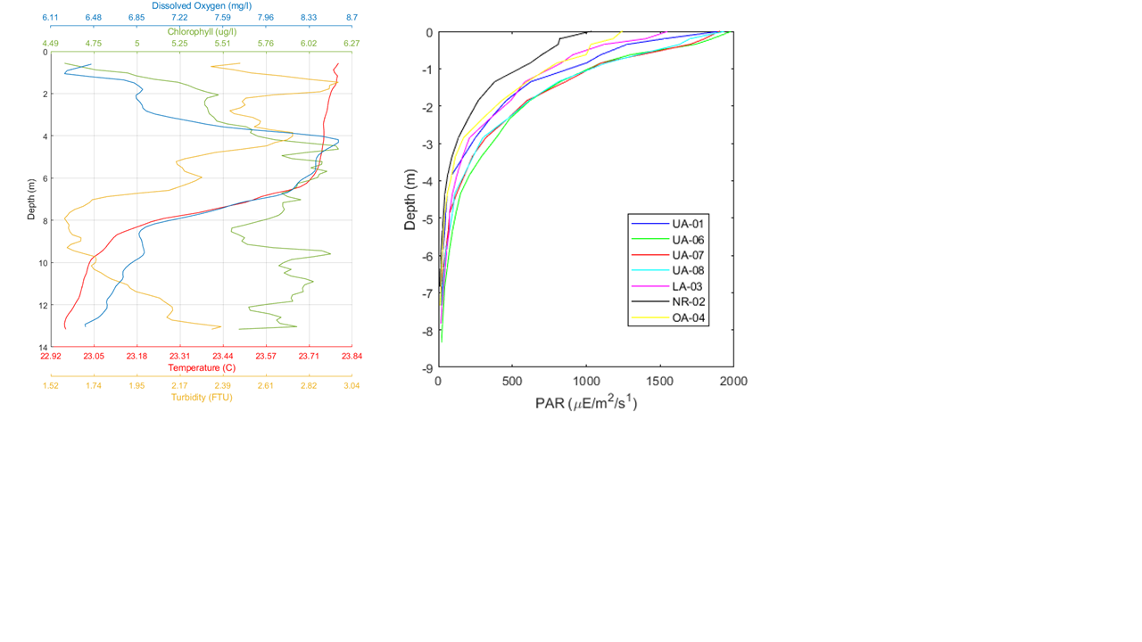

**Fig. 6.** Profiles of temperature, turbidity, chlorophyll and dissolved oxygen measured with our Seabird profiler in the Lower Arm in July 2019 in Clear Lake.

# 

# **Lake Water Quality Sampling**

Lake profiles next to our seven mooring stations every 6 weeks are paired with the collection of discrete water samples at 4 depths at each mooring station. Sampling depths are at 1 m, 2 m, and 4 m above the bottom and 0.5 m below the surface (Fig. 7). The water samples are analyzed for the following nutrients and water quality constituents:

* Nitrogen forms: dissolved nitrite + nitrate (NO2+NO3), total dissolved nitrogen (TDN), particulate nitrogen (PN);
* Phosphorus forms: dissolved orthophosphate phosphorus (SRP), total dissolved phosphorus (TDP), particulate phosphorus (PP);
* Particulate carbon (PC), dissolved organic carbon (DOC);
* Chlorophyll-*a*, phytoplankton identification, and enumeration; and,
* Particle size distribution.

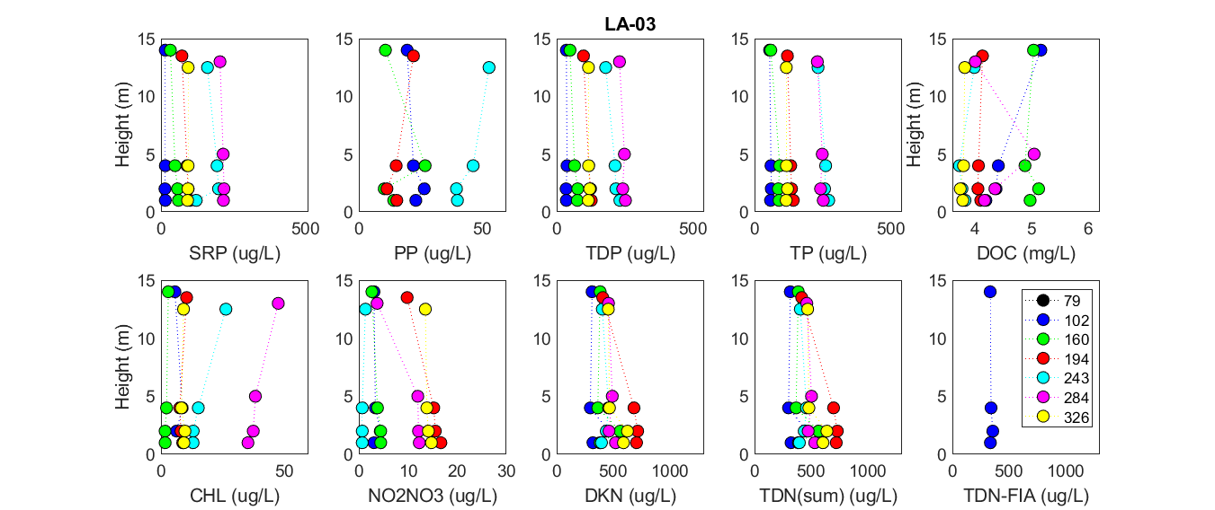

**Fig. 7.** Profiles of water quality constituents measured in Clear Lake in 2019 in the Lower Arm. Note that on the y-axis we show height above the bottom instead of depth